**VEDANT MILIND ATHAVALE  
181090071  
TY BTech EXTC**

**DSP Assignment-4**

**Topic:**We have discussed the utility of the four-step process to compute the response of an actual input from a system characterized by its impulse response. We have also explored the conditions in terms of linearity and time-invariance to be checked for its applicability. Would you like to compare and contrast this process for continuous time case? Illustrate the difference with examples to argue/counter-argue your point.

**Solution:**   
  
The four-step process to compute the response of an actual input signal also known as **convolution** consists of the following steps:

***Flipping Shifting Multiplication Addition***

1. **This process works for a LTI (Linear Time Invariant) Discrete Time Signal.**

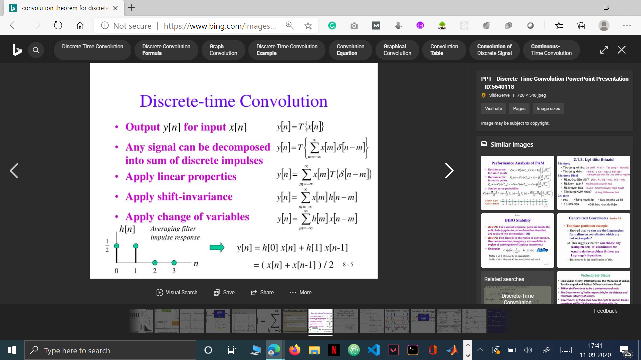

**Convolution Equation for Discrete Time signals**

1. **For a continuous time signal, the process of convolution can be used. It can be used to compute the response of an actual continuous input signal.**

**Limitation** : The signal has to be Linear & Time Invariant (LTI) for convolution to be possible.

Similarly, by carrying out the same steps as we did for LTI Discrete signal, for a LTI Continuous signal, we’ll be integrating.

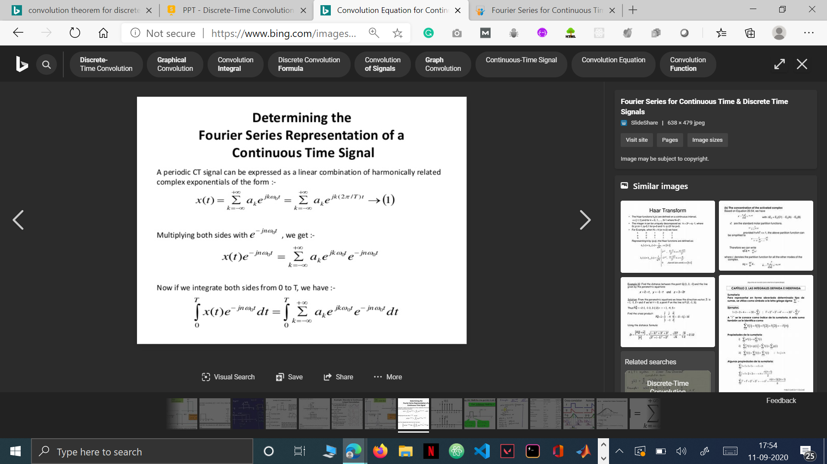

Convolution Equation for Continuous Time signals

1. **A real-life example**

One of the real life applications of convolution is seismic signals for oil exploration. Here a perturbation is produced in the surface of the area to be analyzed. The signal travel(input signal) underground producing reflections at each layer. These reflexions are measured in the surface through a sensors network. The signal obtained is the convolution of the reflection coefficients times the perturbation. Here the signal flips and shifts at the layers underground, get multiplied in magnitude and superposed (added) finally to get an output in the seismograph on the surface of the ground.

**References used:**

<https://www.slideserve.com/shada/discrete-time-convolution> (Image for convolution in LTI Discrete Signal)

<https://www.slideshare.net/jayanshugundaniya9/fourier-series-for-ct-dt-signals> (Equation of convolution in LTI Continuous Theorem)